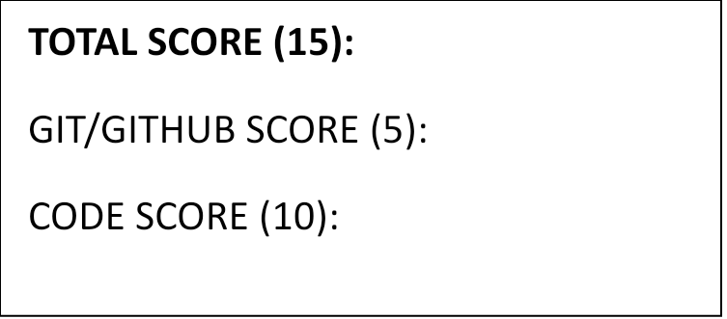

**CSC 202: COMPUTER PROGRAMMING II**

**WEEK NO: __6__ / DAYS COMPLETED ___1_ TO _____**

**PYTHON NINJA LEVEL __Genin_____**

**WEEKLY PRACTICAL REPORT**

**2ND SEMESTER 2023/2024**

**NAME: Oyediran Jomiloju Micheal**

**MATRIC NUMBER: 125/23/1/0183**

**FACULTY: Environmental management and sciences**

**DEPARTMENT: property, surveying, planning**

**PROGRAM: Surveying and Geoinformatics**

**LEVEL: 200 level**

**GITHUB PROFILE NAME: Superb12345**

**REPOSITORY LINK:https://githuGitHub.com/Superb12345/python-replicitexplicitgit**

**LECTURER: Mr. Awoseyi**

Inputfunction.py

print(“Hello world”)

Inputfunction.py

print(len(input("What is your name?")))

printing.py

print("Day 1-python print function")  
print("The function is declared like this")  
print("print('what to print')")

bandnamegenerator.py

print("welcome to the band name generator.")  
city=input("which city you grow up in?\n")  
pet=input("what is the name of a pet\n")  
print("your band name could be"+""+pet)

debugging_practics.py

print("in string manipulation")  
print("string concatenation is done with the '+' sign.")  
print("e.g. print ('hello '+' world')")  
print("new lines can be created with a backlash and n")

variable.py

a=input("a:")  
b=input("b:")

c = a

a = b

b = c  
print("a= "+a)  
print("b"+b)